Forecasting the Outturn Position

  - Introduction

These guidance notes set out the purpose of Budget Forecasting, an overview of the method and details as to how to use the spreadsheet.

Forecasting is a mechanism to estimate the school’s financial position at the end of the financial year. The purpose is to:
- Establish the outturn position
- Monitor budget performance
- Give you time to take remedial action where necessary
- Prompt virement needs
- Assist budget setting for the new year

It is recommended that forecasting takes place at the start of the autumn term, so that 5 or 6 months actual income and expenditure has taken place, on which predictions can be based. The frequency of forecasting outturn depends on the financial position of the school and the overall amount and value of modifications to the original budget.

Under the Scheme for Financing Schools, schools are required to supply the authority with forecasts of income and expenditure at the year-end, prepared at the end of September and December. The forecasts must be in a format and contain those items of income and expenditure prescribed by the Chief Finance Officer and must take account of the deficit/surplus at the previous 31 March.

The Forecast information should be used by Heads and Governors to ensure the budget is managed effectively.

1.2 Forecasting Method

- Start with a fully reconciled report from the school’s accounting package.
- Update staffing estimate calculations with all changes
- Budget Monitor - Review each line of the report produced from your accounting package
- Consider income and expenditure trends and all outstanding projects
- Consider all commitments that are still outstanding
- Enter income and expenditure from your accounting report into the forecasting spreadsheet provided
- Add all projected income and expenditure to the actuals line by line
- Remember to consider SEN Statemented Pupil changes

The opening position, plus actuals to date, plus projections to end of year will result in the forecasted outturn position.

All substantial variances to the original budget plan should be validated for accuracy.

2 Using the Budget Forecast Spreadsheet

2.1 First steps

It is important before beginning to complete this report that you ensure all the budget monitoring has been completed and all queries have been addressed. A reconciliation should be completed monthly to agree all the information being produced by the school to the LA accounts.

The report includes all revenue and capital budget codes.

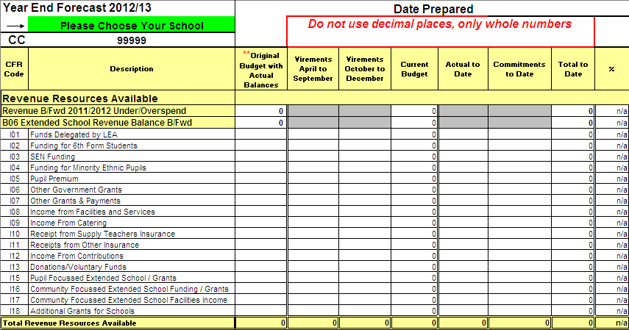

Choose your school name from the drop down box, highlighted in green. This will automatically populate the schools cost centre and the brought forward balances as reported in your previous years outturn report. Next enter the date the report is being prepared, the month up to which the salaries have been paid and posted to the accounting system as well as the date for the non salaried items of expenditure e.g. salaries up to and including August non salaries up to and including September.

In the first column 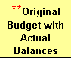 enter the original budget that was submitted to the LA and approved by the Governing Body. The brought forward balances may have been amended to take into account actual balances at the previous year end. Please check your budget as entered on your SAP reports. This is the budget you should enter in this first column.

In the second column 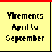 enter the amount of any virement(s) that have been approved in school and entered on to your schools accounting package, these virements will be entered on to SAP after submission of the September forecast.

The third column  is for any virements that have been approved which weren’t included on the September forecast. These columns will be used to update your schools budget held on SAP.

The fourth column  this will give you the current budget position after virements have been applied

Once you have reconciled the budget to the LA and School Report and you are satisfied that all the information is correct you can now complete the rest of the report.

2.2 Entering Income, Expenditure and Commitments

Always use the reconciled information from the school’s accounting package after processing all salary costs to date. These will always be more up to date than the reports sent by the LA.

In the 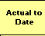 column against the relevant code enter the total income received and the total of all expenditure to date. Check that the total for each category entered on the report agrees back to the totals on the school’s reports produced from the accounting package.

In the 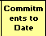 column against the relevant code enter the amount of all outstanding commitments (orders). A check should be made on a regular basis to ensure that all outstanding commitments are still valid.

The 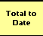 column allows you to compare income, expenditure and commitments against the budget plan up to the date on the report.

The  column allows you to see the percentage of budget spent to the date on the report.

3 Forecasting

3.1 Main Principles

This part of the spreadsheet allows you to enter the future planned income and expenditure.
All budget holders should have an agreed plan which should be reviewed regularly to ensure that the planned expenditure still applies to enable accurate forecasting.

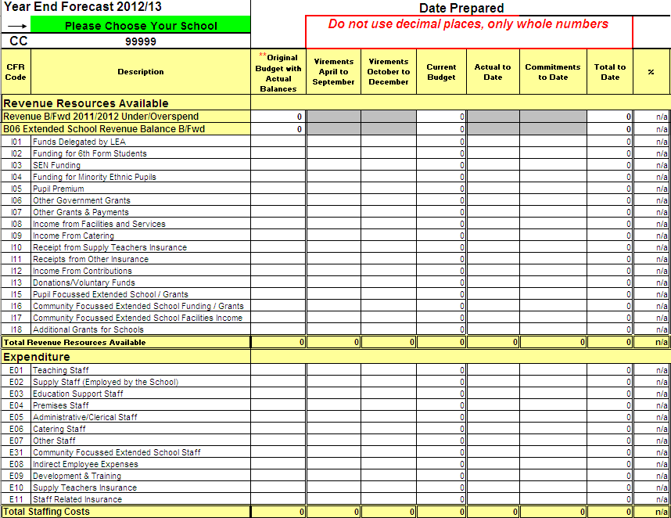

The 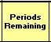 column allows you to enter the number of months that expenditure will take place for example to staff or utility providers. When you are completing this spreadsheet if you have accounted for 6 months actual expenditure, in the Periods Remaining column you will be able to forecast the 6 months that have still to be paid.

The 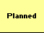column is for you to enter any planned income or expenditure that you anticipate/know will be happening. Throughout this process you will need access to your accounting package to interrogate the data of what has already been paid, making comparisons to previous years spending patterns.

3.2 Examples

Income

Income from LA and the Pupil Premium grant (I01 to I05) This information is updated and published to the Funding and Finance Website on a regular basis so accurate figures are available Funding 2012-2013 Information - Working with children in Barnet

Therefore enter 1 in the No of Months column and the amount of income still to be received from the LA in the “Planned” column. If you are aware of an SEN clawback then please allow for that reduction to income in CFR code I03.

Other Income (codes I06 to I17) When the budget was set at the beginning of the financial year certain facts would have been known or estimated e.g. school meals income, anticipated income from facilities and services. If there is a change from the original estimates or assumptions, the school will need to review the budget and can take account of the change to income (and expenditure if relevant e.g. school meals).

Expenditure

Salaries - if you have accounted for 6 months salaries, you know that 6 months still have to be paid, you will be able to use the information from your September to March staffing estimates. For example, for teaching staff in the Column enter the number of months still to be paid e.g. 6 and in the column enter the amount of the gross monthly figure for January (this should be the same amount for each month). Proceed in the same way for all categories of staff.

Energy costs - can be paid monthly or quarterly and an assessment needs to be made as to the costs for the rest of the year bearing in mind winter usage and any price rises. Enter the No. of months in the column and the average expenditure per month in the column. Please be aware that some invoices are estimated and an investigation into meter readings and amounts owed to or from the supplier will need to take place. Investigation into previous year’s usage patterns will also aid accurate forecasting.

Learning Resources - you need to ensure that you have a record of agreed departmental budgets and that the budget holders understand their budgets. The likely spend should be reviewed on a quarterly basis enabling you to include an estimate of expenditure for the remaining part of the year. Enter a 1 in the column and the anticipated expenditure in the column.

All orders for resources should be issued well in advance of year end in order for the goods to be delivered and paid for before the end of the financial year. If budgets are accurate and dialog with budget holders regular this will make forecasting the resources expenditure less onerous.

Contingency

This is budget provision to cover unforeseen expenditure. The amount of contingency required to support anticipated overspends on individual budgets should be vired to that budget.

When you have completed the forecasting exercise and you feel the information is reasonable the 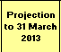column will show the anticipated outturn position to the end of the financial year for each budget heading. This can change at any time due to unforeseen circumstances and staffing changes etc.

The column allows you to see the forecasted percentage of budget spent using the projected figures on the report to the end of the financial year.

The 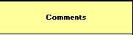 column allows you to annotate any variances or reasons for budgets being overspent.

4. Capital

Capital income and expenditure should be addressed in exactly the same way as Revenue. With capital the projects are known and the estimates agreed what you need to allow for is any additional costs arising from the project. If there are additional associated costs and they have been agreed to be taken from the revenue budget then allowances should be made to direct revenue financing to take account of the changes.

5. Queries

Any queries about the requirements of the Scheme for Financing Schools in relation to the production of forecasts contact Kim Garrood on 020 8359 7225 or email kim.garrood@barnet.gov.uk

Any queries about the possible claw-back of surplus revenue balances should be referred to Nick Adams, Schools Finance Services Manager on 020 8359 7203 or email nick.adams@barnet.gov.uk.

To those of you purchasing the Helpdesk service that need advice on using the spreadsheet please contact the School Support Helpdesk on 8359 7231 or email schools.support@barnet.gov.uk.

